MuleSoft Anypoint Platform
Experiment 3

Problem Statement:
Create a Mule project to access the external API using Request Component.
Solution:
Steps:
- Navigate to Open Anypoint Studio and define your workspace.
- Go to File ➜ New ➜ Mule Project Or you can continue in your existing one
- Enter Project Name: HelloMule, then click Finish.
- 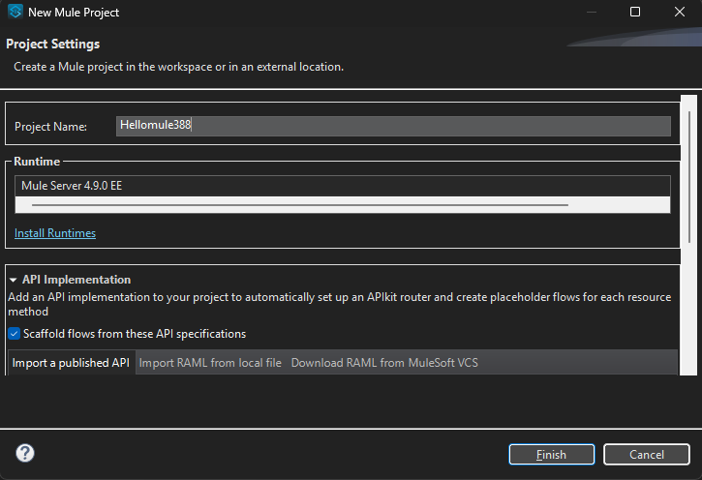

- Design the Flow
  - Add HTTP Listener :
    - Open the HTTP module.
    - Drag HTTP Listener onto the canvas
    - 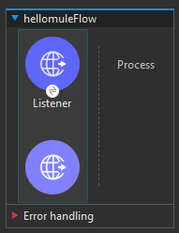
  - Configure HTTP Listener:
    - Click the component; in Properties, click + to add a global configuration:
      - Host: 0.0.0.0 and give port as 8081
      - 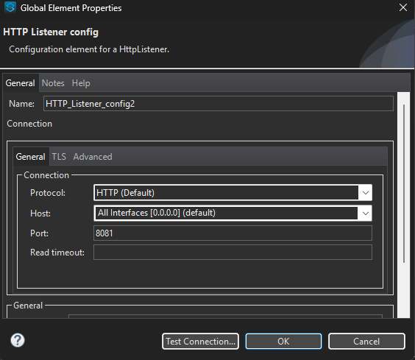
      - Under General, set Path: /hellomule
      - 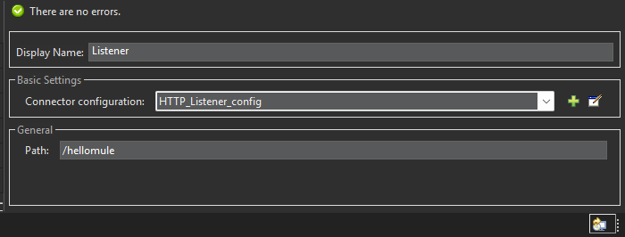
  - Add Request (HTTPS) from the favorites
    - 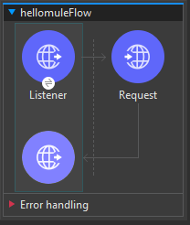
    - In the Properties panel, in basic settings -> Configurations click on new and click ok.
      - 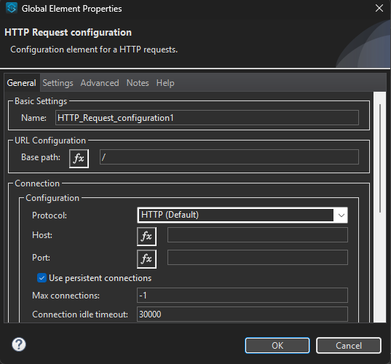
  - In the request keep the method as GET and then for the path give it as
https://jsonplaceholder.typicode.com/users.
  - 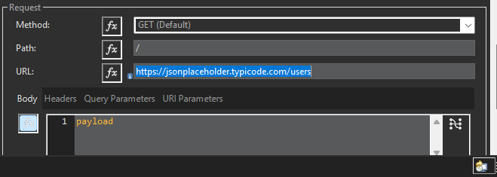
  - Save the files.
  - Right-click on the canvas ➜ Run project 'HelloMule'.
  - Monitor the Console until you see “DEPLOYED” .
  - Go to your browser and then type this web address: “localhost:8081/hellomule”
  - You should see a output like this.
  - 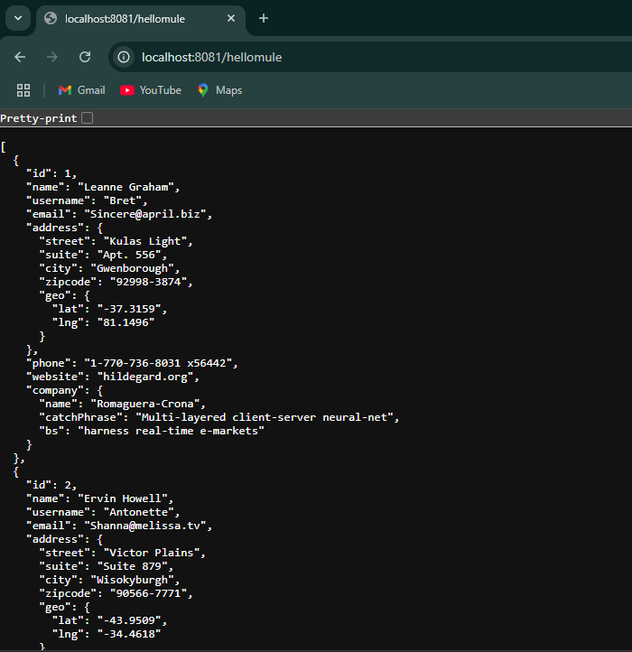
  - With Query Parameters:
    - In the request add the query parameter for example let us take id : 1
    - 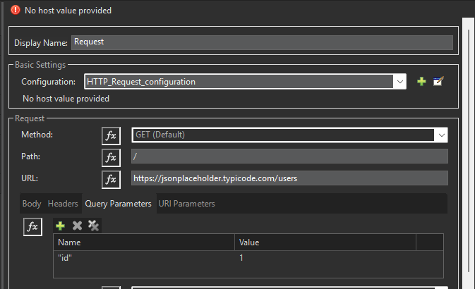
    - Save the flow and re run the project.

    - Go to localhost:8081/hellomule and you will see output like this

    - 